# Week 4 Submission Group: 19

Word limit=1000. Use bullet points and be concise. Cite reference

# Project Update: 1 point

1. What is the purpose and task in this step?

The purpose of this step is to provide progress of our CNC soldering machine. This involves manufacturing and assembling prototype parts and evaluating these solutions for the next iteration of prototypes.

1. What did you achieve in this step? Also submit a short video to show the construction and test of your prototype (1-2 min, feel free to include texts, pictures, animations, etc. in your video).

In this step, we manufactured parts required for a prototype. We submitted a video showing the assembly of the prototype. Unfortunately, not every part could be printed in time as well as some parts failing to print.

Each manufactured part has been evaluated and changes will be made to some of them:

* The solder feeder holder will be optimised for 3D printing.
* Plastic placeholder parts will be made with sheet metal.
* A new bracket for the vertical motor will be redesigned as the current design is not sufficient for its weight.

# Homework: 1 point

1. Show answers with explanation/procedures for Homework Questions given in this week lectures.

Questions:

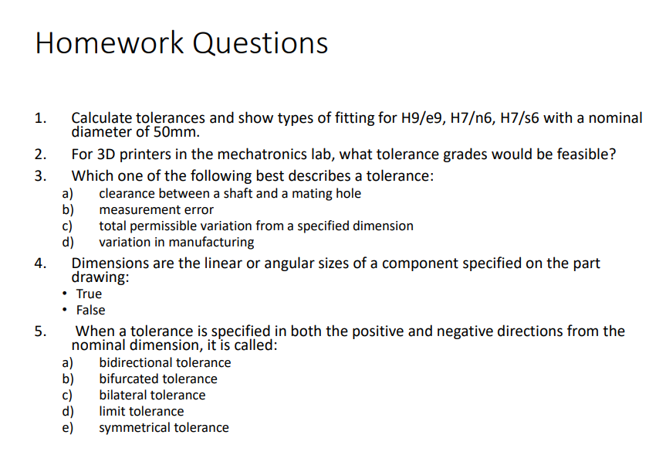

1. H9/e9 Clearance fit, hole tolerances +0.062mm, -0.00mm

Shaft tolerances -0.050mm, -0.112mm

H7/n6 Transition fit, hole tolerances +0.025mm, -0.00mm

Shaft tolerances +0.033mm, +0.017mm

H7/s6 Interference fit, hole tolerances +0.025mm, -0.00mm

Shaft tolerances +0.059mm, +0.043mm

1. The z axis tolerance is 0.1mm, The x and y axes’ tolerance is 0.3mm. The diameter of the nozzle can be either 0.4mm or 0.6mm.
2. total permissible variation from a specified dimension
3. True
4. Bilateral tolerance

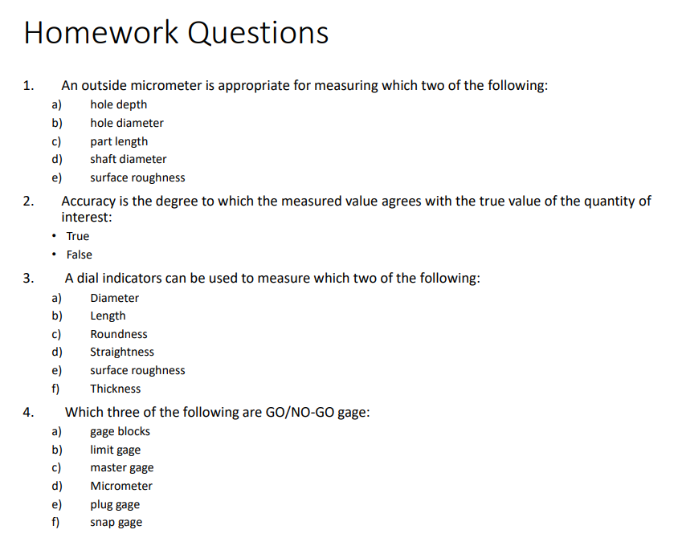

1. shaft diameter, part length
2. True
3. Straightness, surface roughness
4. limit gauge, plug gauge, snap gauge

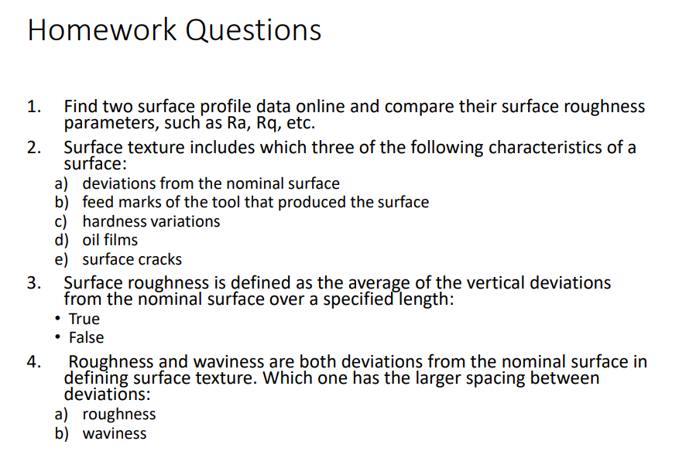

1. Surface profile parameters of machined surfaces using confocal displacement sensor and stylus profilometer (1)

|  |  |  |  |  |  |  |  |  |
| --- | --- | --- | --- | --- | --- | --- | --- | --- |
| Machining | R_a | Surfaces profile parameters (µm) | | | | | | |
| Confocal Displacement Sensor | | |  | Stylus profilometer | | |
| R_a(c) | R_q(c) | R_t(c) | R_a(stylus) | R_q(stylus) | R_t(stylus) |
| Turning | 1.6 | 2.2250 | 2.6820 | 13.1266 | 1.736 | 1.990 | 7.93 |
| 3.2 | 3.5662 | 4.0940 | 16.4505 | 2.243 | 2.569 | 9.53 |
| 6.3 | 6.8455 | 7.9286 | 31.3377 | 5.739 | 6.487 | 24.02 |
| Horizontal Milling | 1.6 | 1.6898 | 1.9958 | 8.0386 | 0.445 | 0.549 | 2.68 |
| 3.2 | 3.2905 | 4.1060 | 23.4659 | 0.509 | 0.770 | 3.08 |
| 6.3 | 6.7000 | 7.7703 | 37.5313 | 1.428 | 2.018 | 13.37 |
| Vertical Milling | 1.6 | 1.9851 | 2.3965 | 12.1622 | 1.418 | 1.758 | 8.53 |
| 3.2 | 3.5127 | 4.3704 | 20.6980 | 3.332 | 3.819 | 15.50 |
| 6.3 | 6.1992 | 8.4885 | 50.6272 | 7.607 | 8.677 | 17.71 |

Surface profile parameters of machined surfaces obtained using Perthometer (2)

|  |  |  |
| --- | --- | --- |
| Machining  Process | Standard Sample,  Ra in µm | Calculated Ra using  Perthometer, in µm |
| Horizontal  Milling | 0.4 | 0.4045 |
| 0.8 | 0.7224 |
| Turning | 1.6 | 1.6564 |
| 3.2 | 2.2869 |
| 6.3 | NA |
| 12.5 | 11.5031 |
| Vertical Milling | 0.4 | 0.4206 |
| 0.8 | 0.7654 |
| 1.6 | 1.5006 |
| 3.2 | 2.9854 |

Although both online sources show different roughness of surfaces using different machining processes, Horizontal milling is shown to be the smallest average roughness. Turning has a lower average than vertical milling at a small Rz but becomes rougher than vertical milling at large Rz.

1. deviations from the nominal surface, surface cracks, feed marks of the tool that produced the surface
2. True
3. Waviness

1. Total runout is when any part of the circular surface can be out by the tolerance whereas for cylindricity, when it's sliced down a perpendicular plane, it must be perfectly circular.
2. Grinding
3. Sand casting

# Weekly Individual Contributions

|  |  |  |  |
| --- | --- | --- | --- |
| Name | Contributions | Mark | Signature |
| Reuben | Helped answer homework questions, 3d printed some of the parts, helped with the assembly video, | 2 | Reuben |
| John-Luke | Helped with homework, designed and cut the sheet metal supports, helped with the assembly video. | 2 | John-Luke |
| Jack | Helped answer homework questions and with showing how the CNC machine is assembled and would operate. | 2 | Jack |
| Lucas | Helped with homework, designed and 3D printed solder holder, helped with the assembly video. | 2 | Lucas |
|  |  |  |  |
|  |  | Sum=2*N |  |

N: number of group members. Every group member is expected to take part in the whole process, not just work on one part, for example, report writing only.

# Reference

References will not be included in word count

1. <https://www.sciencedirect.com/science/article/pii/S2211812814008219>
2. <https://www.researchgate.net/publication/359928103_Scope_of_Confocal_Displacement_Sensor_in_the_field_of_surface_metrology>